The Excel spreadsheet is where you’ll provide details on your proposed activities for the fiscal year, their expected outcomes, and the amount of money you are requesting from HCTF.
The excel document contains two separate worksheets (“Fiscal Budget” and “Multiyear Budget”) that can be accessed via the tabs at the bottom of the screen:
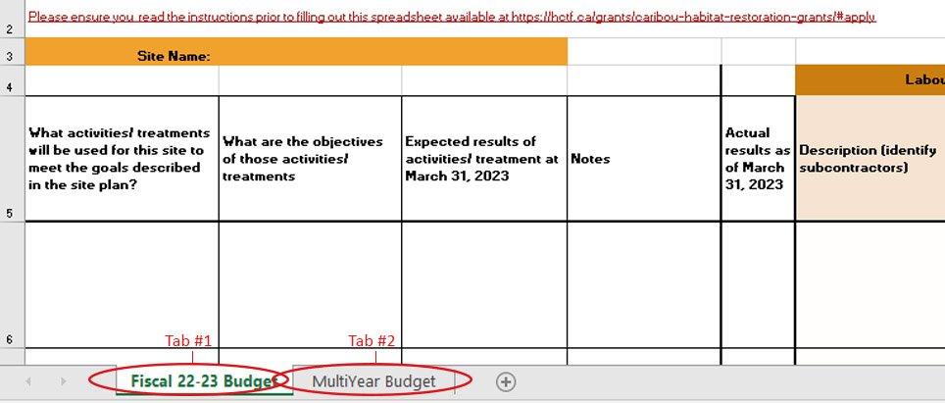

Instructions for completing the “Fiscal Budget” spreadsheet (Tab #1):
- Add the restoration site name at the top of the form (please ensure this matches the site name you used in question #1 of the CHRF application form).
- In column A, describe each activity for which you are requesting HCTF CHRF funding. Please ensure they all comply with the CHRF Eligible Activities List. Please see example posted at https://hctf.ca/grants/caribou-habitat-restoration-grants/#apply. Currently, there is room to provide details for 7 different activities at each site. If you need to add more, please follow the directions provided in the spreadsheet to avoid formula issues. If you require assistance, please contact chrf@hctf.ca or call 250-940-9789.
- In column B, enter the objective of the activity/treatment.
- In column C, enter the expected results of the activity/treatment. These need to be measurable. Please see example posted at https://hctf.ca/grants/caribou-habitat-restoration-grants/#apply .
- In column D, please include any notes that you feel would be helpful to those reviewing your application.
- In columns F, G, I, J, L and M, provide details on the money you are requesting from HCTF for each activity. Please break down the budget for each activity by Labour, Materials, and Travel.
  - Labour: please include the number of person days and day rate in the description field. Salary/wages for regular government employees are not an eligible expense.
  - Materials: please note that capital assets (items with a per unit cost over $1000) are not eligible for funding under this program.
  - Travel: HCTF pays mileage at a rate of $0.54/km.
- Cell O17 is where you’ll enter any overhead costs or administration fees for the project. Please include a brief explanation of how this fee was calculated in the blue text field.
- If direct overhead costs are being charged to HCTF (phone, office supplies, etc.), then there should not be an administration fee (% of eligible costs) charged.
- It is assumed that contractor/consultant overhead costs are included in their day rate. If their costs are billed separately, you can include it here.
- Direct (i.e., internal) administration fees are not permitted on project proposals submitted by Provincial Government applicants.
- Applicants can request administration fees up to a maximum of 15% against eligible costs.
- Notwithstanding these guidelines, funding for overhead and administration costs is subject to available funds, and at its discretion, HCTF may reduce funding requests for overhead costs and administration fees.
- The “Other Funding Sources” table, is where you will provide information on cash and in-kind support for the project from other organizations. Priority will be given to proposals demonstrating they have secured significant in-kind/cash support. We encourage applicants to target a 0.5 to 1 funding match.
In-kind contributions are the provision of goods or services necessary to carry out the project activities. These are valued in monetary terms and accounted for as part of the partner’s contribution to the budget (i.e., goods or services which are donated, but for which you would otherwise have to pay). For example:
Goods: Construction materials or other specialized materials, equipment, etc.
Services: Use of facilities, professional services, expertise (e.g., staff time), equipment and operator, etc.
If there are both Goods and Services contributions from a partner, please enter each on separate lines. If a partner is contributing both in-kind and cash to your project, you may enter those on the same line.
In the light orange box under the table, please provide an explanation of how you calculated the monetary value of any in-kind contributions (e.g., for professional services identify how many hours or days and at what rate).
Note that the Total Contributions from Other Funding Partners (green cell) should match the “Total Other Funding” value for this fiscal in the Multi-Year Budget Table (see instructions below).
Additional Instructions for the Activity and Budget Detail Spreadsheet:
The “Total” cells and columns are designed to populate automatically, so please avoid editing the formulas.
Note on hidden columns: You may notice that there are some hidden columns in the spreadsheet. These will be used in the reporting stage of approved applications, so please do not edit or delete them; they have only been hidden to avoid confusion/data entry errors and to make the spreadsheet more manageable at the application stage.
Instructions for completing the “MultiYear Budget” spreadsheet (Tab #2):
The multi-year budget table is an “at-a-glance” view of projected funding requests for this project: you only need to complete this spreadsheet if you are planning to apply for multiple years of funding from HCTF. If you do not anticipate asking HCTF for more money for this project in future years, you do not need to fill out the multiyear budget table.
- In column B “Fiscal Year”, enter the fiscal year for which you are requesting funding and any future years that you anticipate requesting funding for this project (up to a maximum of 5 years).
- In column C “$ Requested from HCTF”, enter the amount you are requesting from HCTF for this fiscal (ensure that the amount entered matches the total in the Part 2 spreadsheet). Then, enter your projected funding request from HCTF for this project in future years. It is expected that the multi-year budget plan outlined here will be maintained in future proposals. Any variances will need to be supported by a rationale in future applications.
- Column D “HCTF $ Approved” is where you will record HCTF CHRF funding approved for each year of the project.
- Column E “Total Other Funding” is where you’ll enter the total amount of cash and in-kind contributions that you anticipate receiving for each year of the project. The amount you enter for this fiscal should match the “Total Contributions from Other Funding Partners” (green cell) from the first tab of the workbook.
- Column F “Total Annual Budget” will be automatically calculated: it is the total of HCTF and other contributions for the project.
- If you feel a brief explanation is necessary for any of the information you’ve entered in the multiyear budget table, please enter it in the space provided.

Questions?
If you have any questions about how to complete your application, please contact chrf@hctf.ca or call 250-940-9789.

